The Science Behind GyroStim…
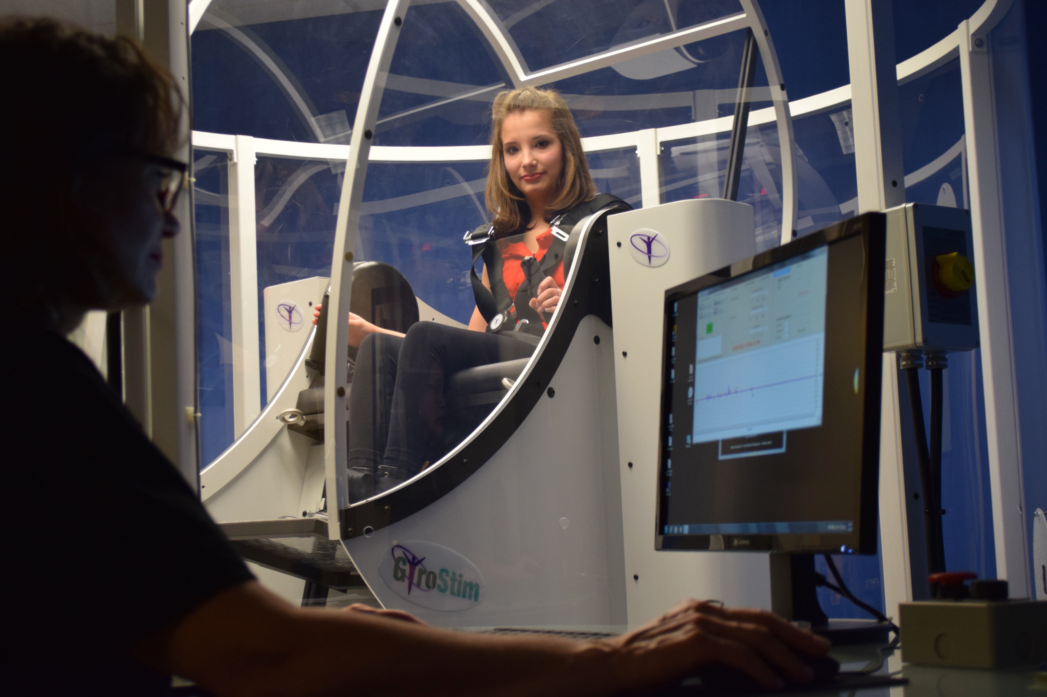
Precision Multimodal Neurotechnology | Computer-Controlled Multi-Axis Rotational Chair

The neuroscience principles behind GyroStim are well established. For decades, clinicians have used vestibular, visual, motor, somatosensory, and cognitive stimulation, along with therapeutic challenges to promote neuroplasticity, adaptation, and functional recovery. [1–3,11]
The complex, interconnected roles of these systems in movement, balance, sensory integration, cognition, and functional performance are well documented, as is their use in vestibular, physical, occupational, and neurological rehabilitation. [1–6,11–13] Their interdependence provides the scientific foundation for multimodal neurorehabilitation, combining sensory, motor, and cognitive challenges to simultaneously engage multiple systems and promote the integrated processing and adaptive responses essential to everyday function. [4–6,12,13]

Although effective, conventional neurorehabilitation remains constrained not by the underlying neuroscience, but by the practical limitations of treatment delivery. [1,7,11] Manually administered rehabilitation is limited by what clinicians can physically deliver and what patients can safely and effectively perform, placing practical constraints on the precision, repeatability, intensity, complexity, and progression of multimodal neurological stimulation, and potentially limiting the full therapeutic benefits these approaches can achieve.
Taking Multimodal Neurorehabilitation
to the Next Level.
GyroStim addresses these limitations by bringing five interconnected neurological systems together within a single, computer-controlled platform—enabling precisely coordinated, repeatable, measurable, and progressively challenging multimodal neurorehabilitation: [8,9]
Vestibular + Visual + Motor + Somatosensory + Cognitive
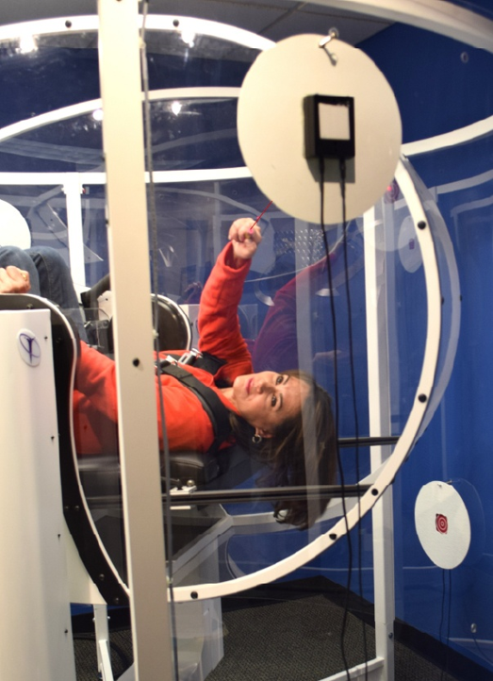
Contemporary neuroscience demonstrates that the brain does not process sensory, motor, and cognitive information independently, but instead integrates these functions through complex, interconnected neural networks. Modern neurorehabilitation increasingly incorporates multisensory and multimodal approaches that simultaneously engage and progressively challenge these networks to promote neurological adaptation and functional recovery. Reviews in stroke, dementia, and neurological rehabilitation report promising functional benefits from these approaches. [12–15]
GyroStim takes the principles of multimodal neurorehabilitation to the next level by integrating advanced robotic automation, computer-controlled precision, and data-driven treatment progression into a powerful clinical platform that overcomes the inherent limitations of manually administered neurorehabilitation. [7–9,11]

Unlike manually administered therapy, GyroStim can deliver technology-assisted, precisely coordinated, simultaneous stimulation of multiple neurological systems with a level of consistency, complexity, and progressive control that extends well beyond the practical capabilities of conventional rehabilitation methods. Within this dynamic environment of precisely controlled, whole-body motion, the patient is continuously challenged to process changing sensory information, integrate multiple inputs, maintain spatial orientation and situational awareness, coordinate motor responses, engage cognitive and executive functions, react quickly, solve problems, and adapt in real time. These simultaneous demands more closely reflect real-world function, where sensory, motor, and cognitive systems must continuously operate together rather than in isolation. [4–6,8,9]

With data-driven adaptability, GyroStim can further amplify this integrated neurological challenge. [8,9] Within a precisely controlled, physically supported environment, clinicians can progressively increase the intensity, complexity, and combination of these demands beyond what many patients could safely perform independently and beyond the practical limits of many conventional rehabilitation activities.
The GyroStim Advantage: Expanded Clinical Capabilities
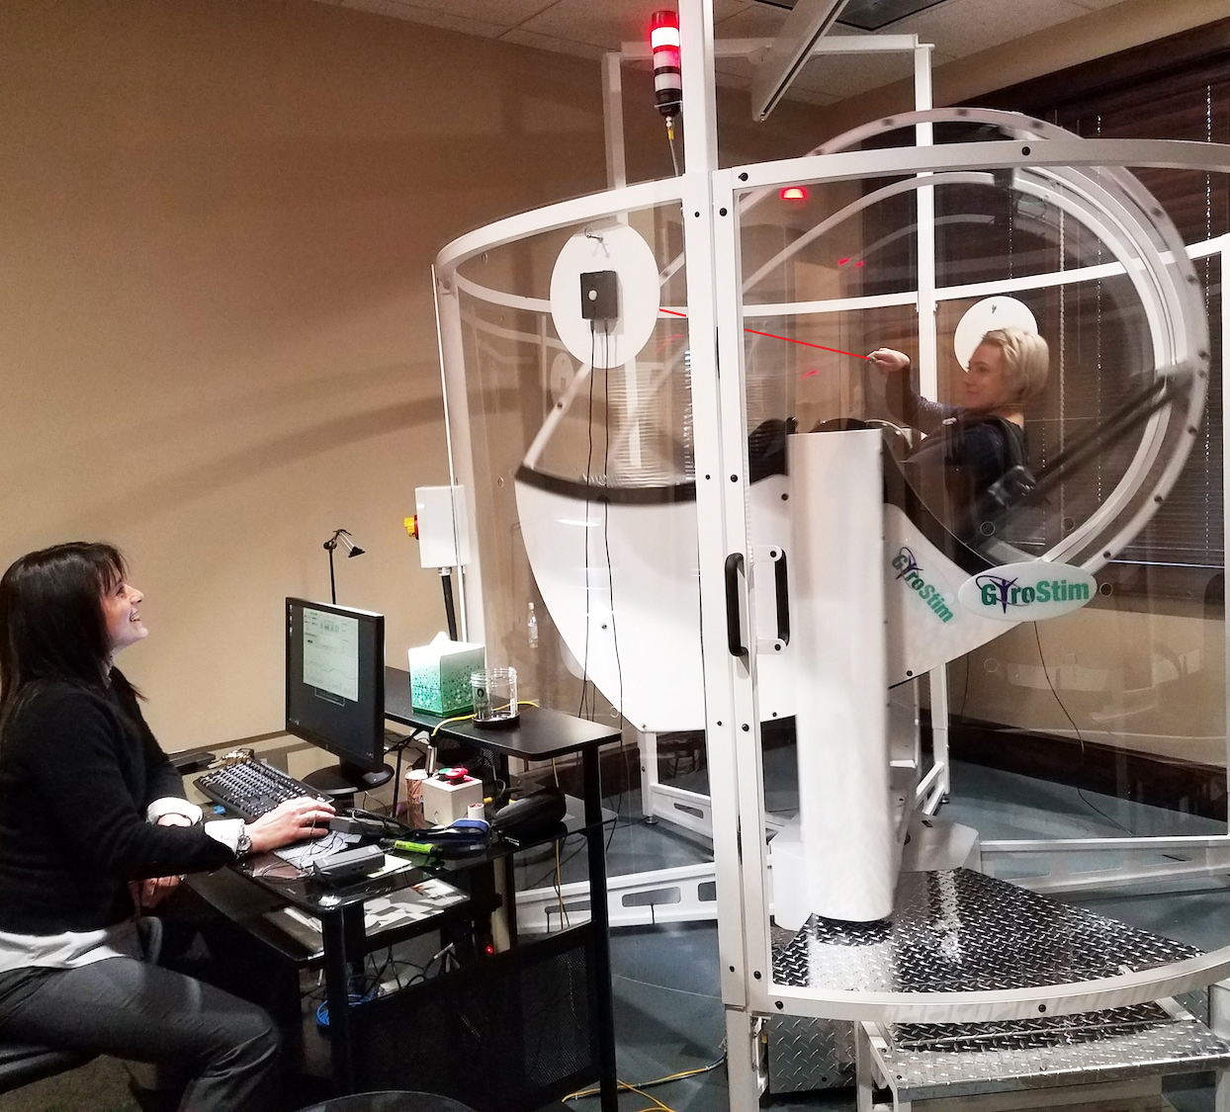
- Precision and repeatability. Computer-controlled multi-axis motion delivers precisely dosed, reproducible vestibular stimulation with adjustable intensity, duration, and complexity, overcoming the inherent limitations of manually administered interventions. [8,9]
- Simultaneous multisystem engagement. Coordinated stimulation of vestibular, visual, motor, somatosensory, and cognitive systems challenges the brain to continuously process, integrate, and respond to multiple streams of sensory information. [4–6,9]
- Interactive visuomotor stimulation. Laser-targeting activities challenge visual tracking, hand-eye coordination, motor accuracy, reaction time, and sensorimotor integration during dynamic motion. [9]
- Integrated cognitive stimulation. Concurrent cognitive tasks challenge attention, processing speed, memory, decision-making, problem-solving, and executive function under progressively demanding conditions. [7–9]
- Dynamic spatial and sensory processing. Changing motion and body position challenge proprioception, spatial orientation, situational awareness, and the ability to interpret and adapt to continuously changing sensory inputs. [4–6]
- Individualized, data-driven treatment progression. Clinicians can adjust therapeutic intensity, duration, and complexity according to each patient's capabilities, objective performance measurements, physiological responses, and tolerance, allowing treatment to be progressively advanced as function improves. [8,9]
- Expanded therapeutic capabilities in a physically supported environment. The secured, seated configuration reduces fall risk during therapy, enabling clinicians to deliver increasingly complex neurological challenges without requiring patients to independently maintain standing balance, expanding treatment possibilities for patients with significant functional limitations. [8,9]
- Scalable, standardized implementation across healthcare networks. Robotic automation, reproducible treatment protocols, objective data collection, and data-driven progression provide a foundation for consistent, high-quality neurorehabilitation delivery across multiple clinicians, facilities, and healthcare networks, supporting standardized clinical protocols, centralized performance monitoring, and large-scale program implementation. [8,9,16]
From Technological Capability to Clinical Evidence

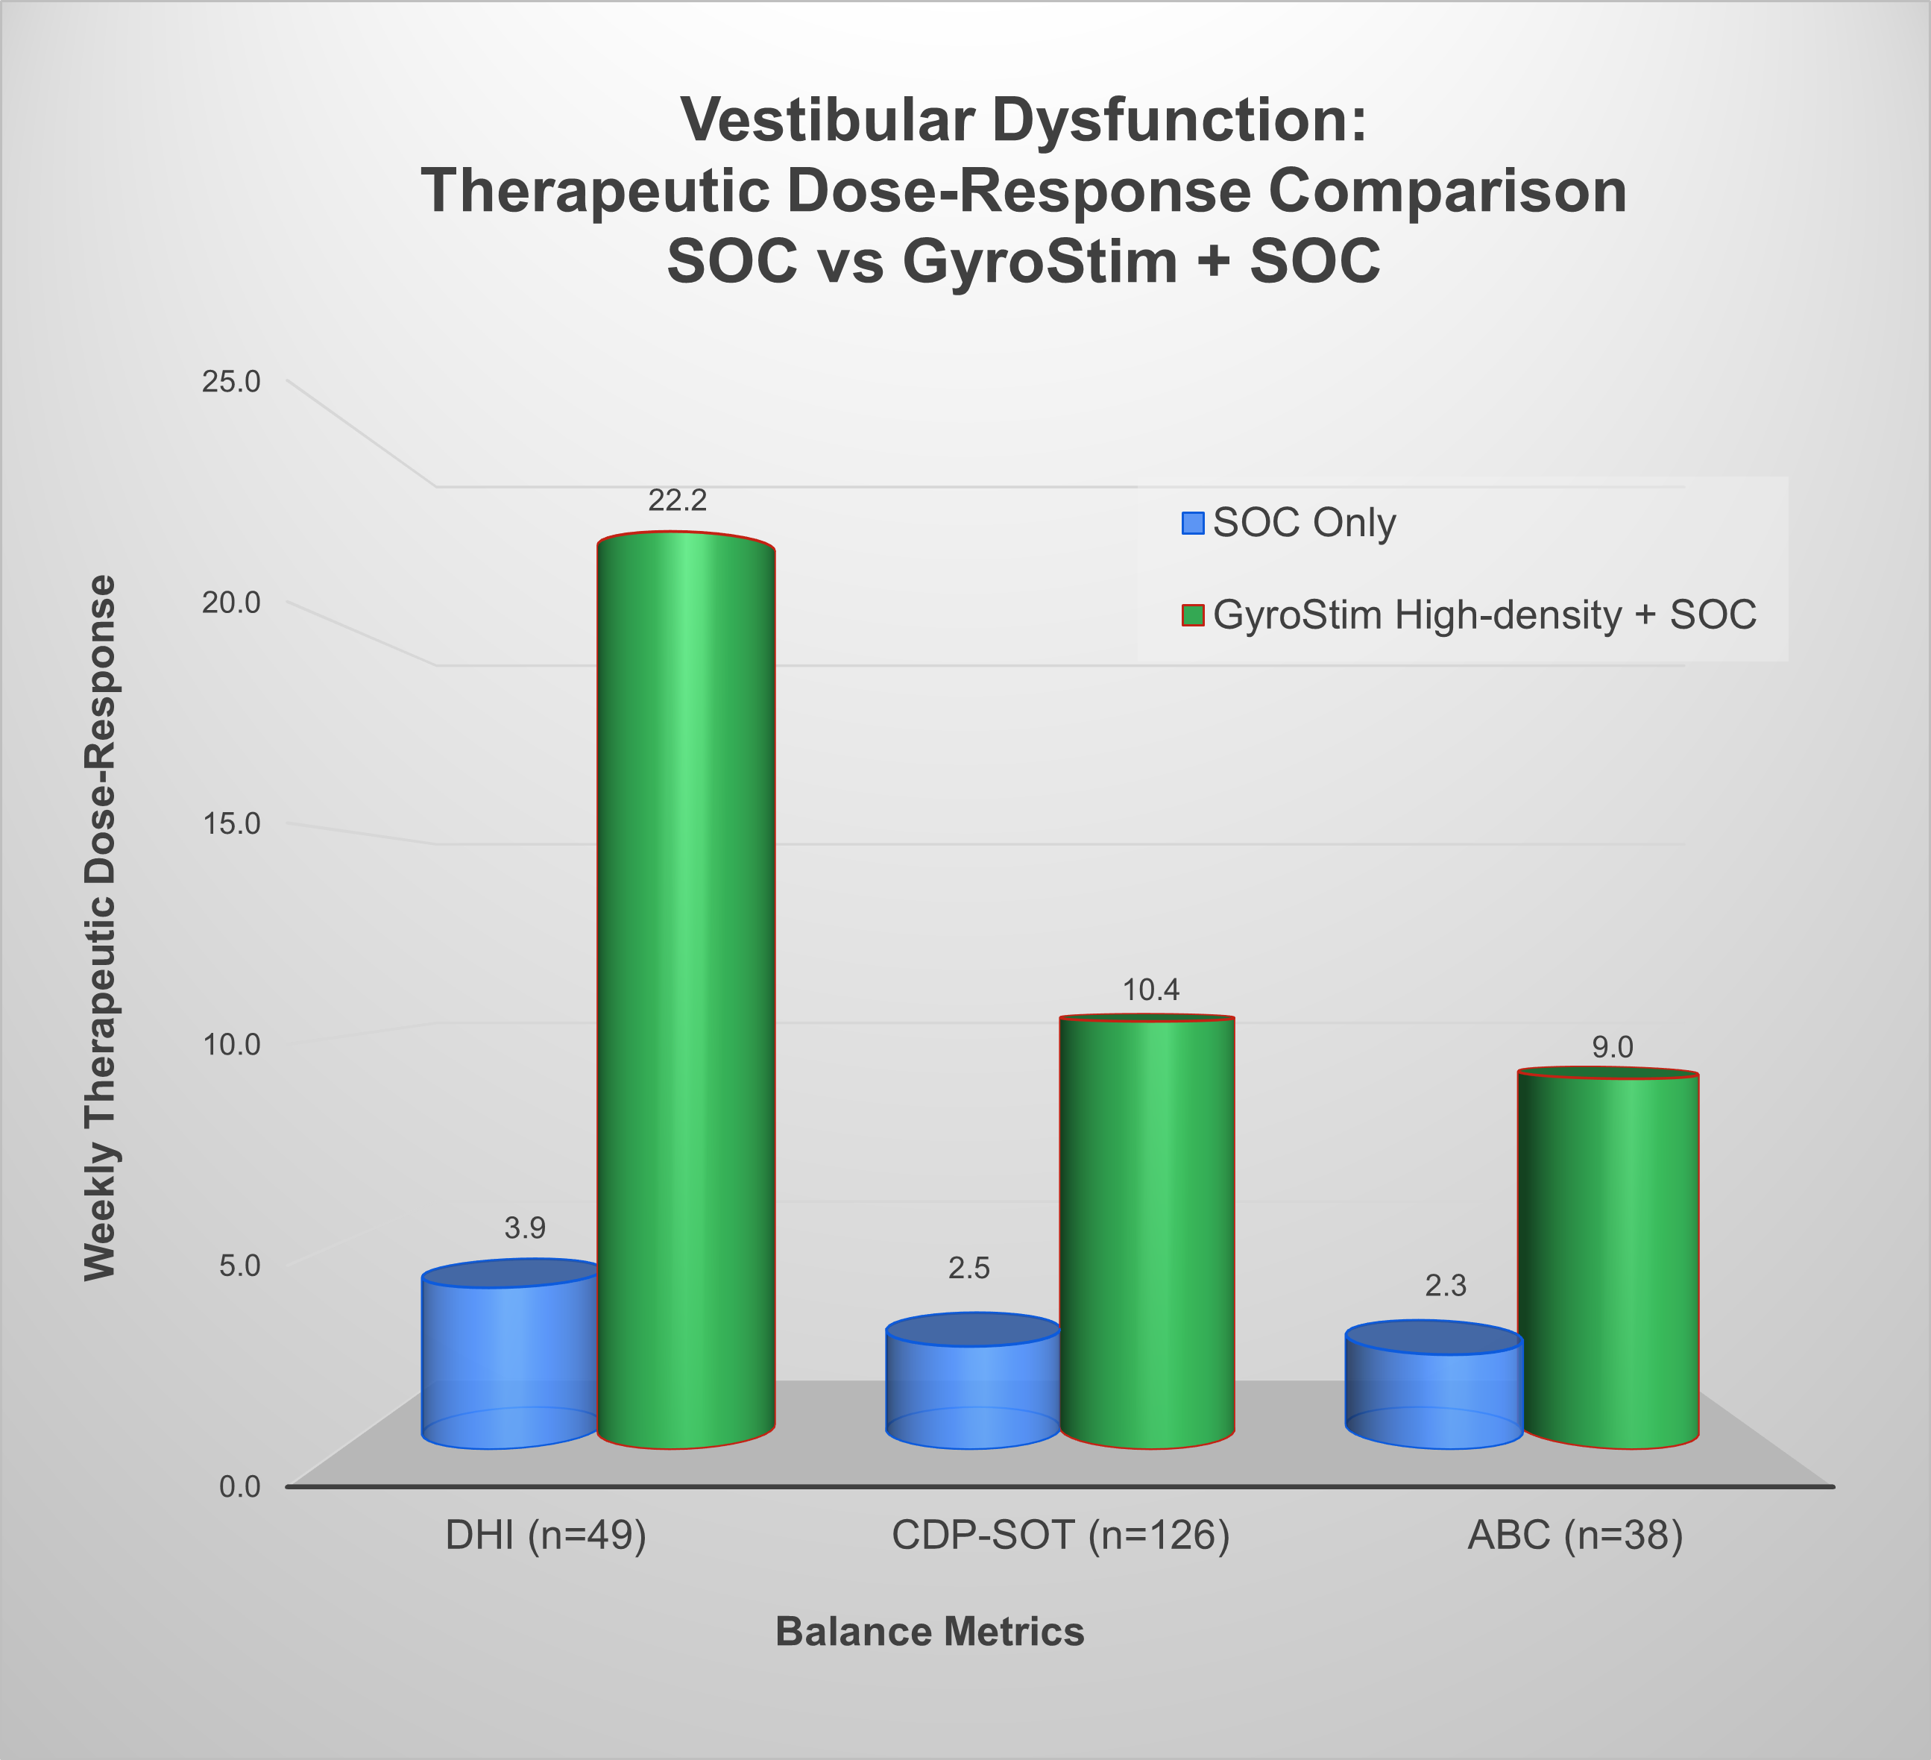
GyroStim's advanced technological capabilities enable clinicians to deliver sophisticated multimodal neurorehabilitation with exceptional precision, consistency, and progressive control. The more important question, however, is whether these capabilities translate into measurable clinical benefits.

Real-world clinical evidence provides encouraging answers. In a recent retrospective analysis, High-Density GyroStim + SOC was associated with approximately 3.9–5.7× the weekly rehabilitation efficiency of SOC Only across three complementary balance outcome measures. [8]

Importantly, this rehabilitation-efficiency advantage was observed across a clinically diverse population representing multiple conditions and presentations associated with balance disorders and vestibular dysfunction. These findings suggest that GyroStim-assisted multimodal neurorehabilitation may substantially accelerate rehabilitation across diverse patient populations requiring vestibular rehabilitation. [8]

FDA Clearance and Breakthrough Device Designation
FDA-cleared and recognized by the FDA with its prestigious Breakthrough Device designation, GyroStim represents a major technological advancement in the delivery of multimodal neurorehabilitation, distinguished by rigorous regulatory review, clinical innovation, and the potential to transform the treatment of conditions associated with vestibular dysfunction. [9,10]
These landmark regulatory achievements distinguish GyroStim as a significant advancement in precision neurotechnology, combining distinctive FDA recognition with breakthrough technological capabilities that expand the possibilities of technology-assisted multimodal neurorehabilitation. [9,10]
GyroStim is FDA-cleared to assist in the treatment of balance disorders and vestibular dysfunction and is designated by the FDA as a Breakthrough Device. [9,10]
Established Science. Breakthrough Technology. Outstanding Results.
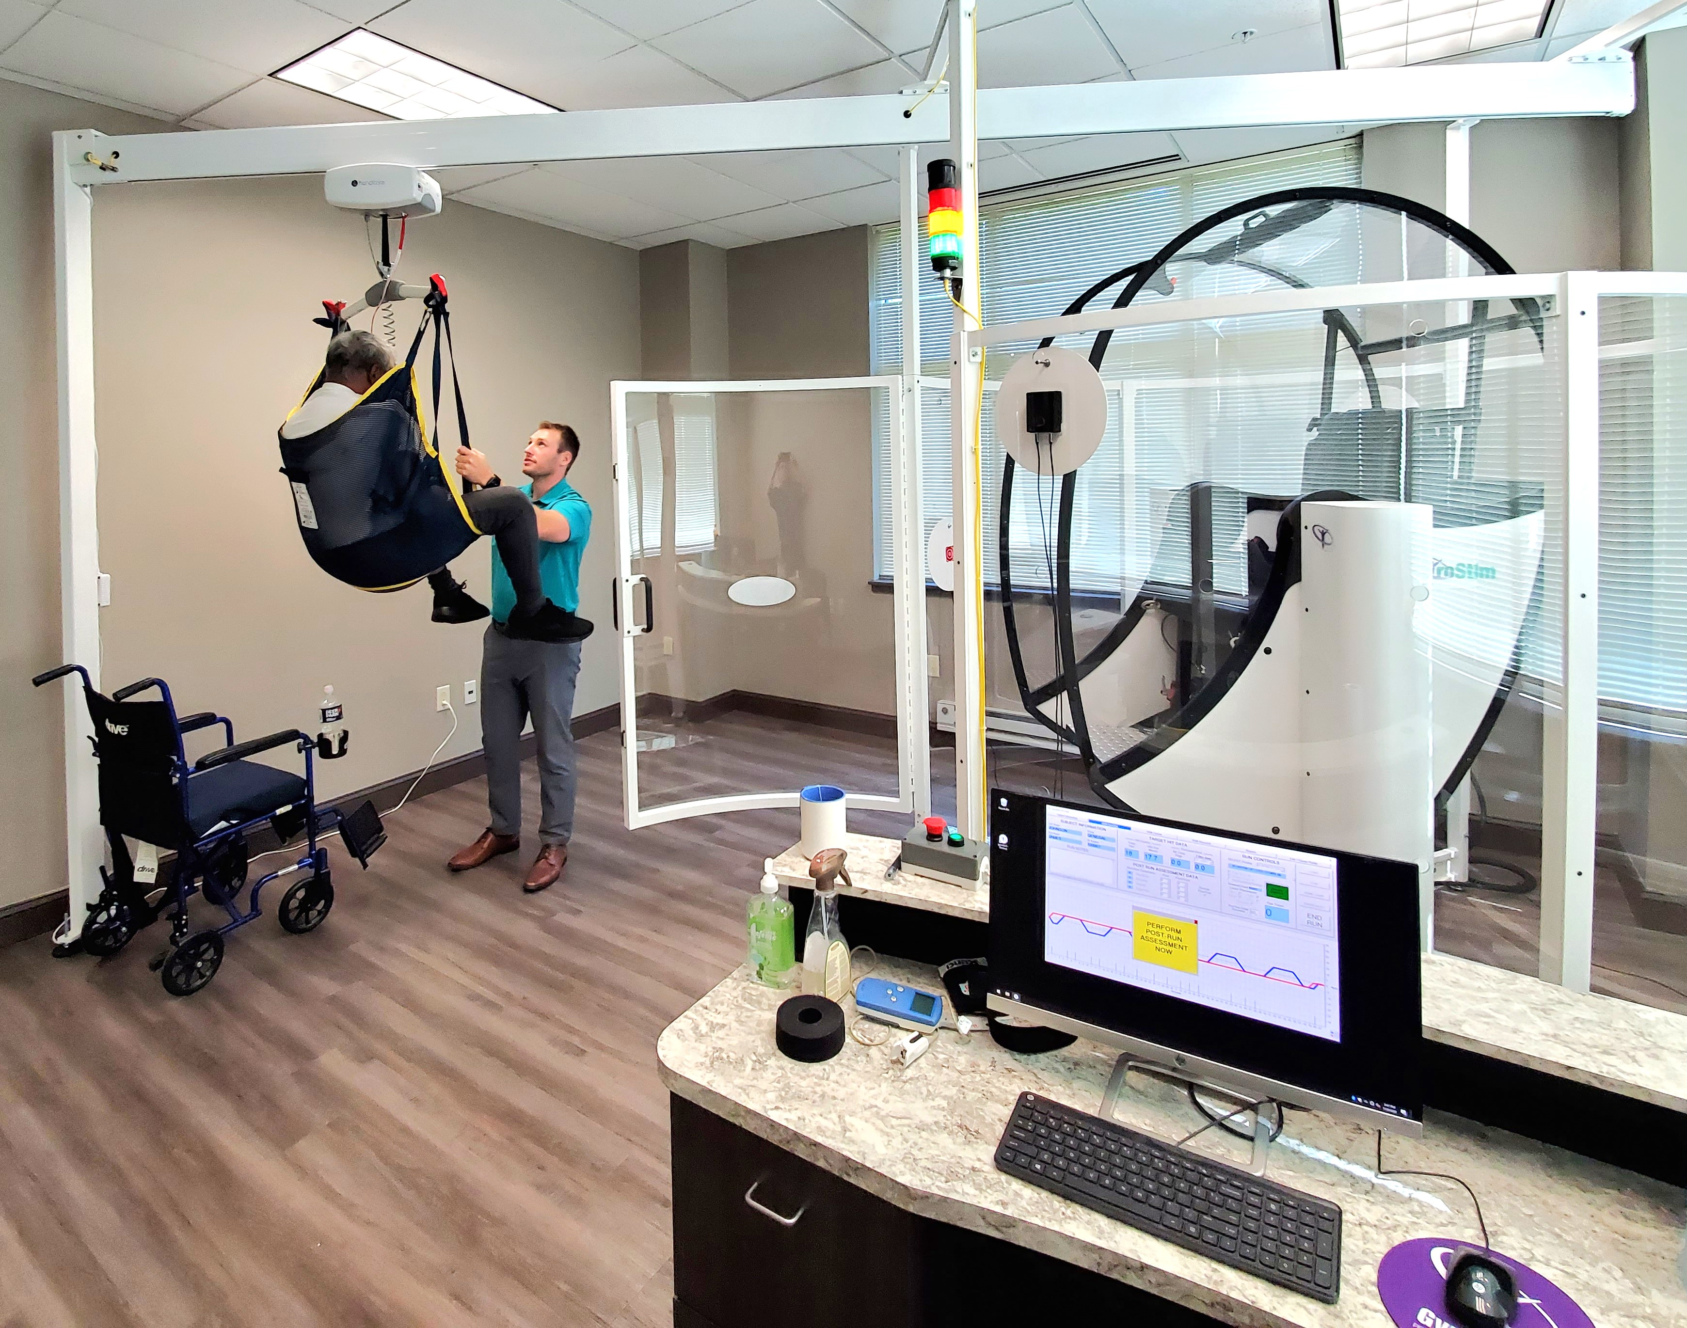
Discover more at GyroStim.com

UltraThera Technologies, Inc. | © 2026

References
Selected peer-reviewed literature and regulatory/clinical sources supporting the scientific rationale described in this document.
[1] Hall CD, Herdman SJ, Whitney SL, et al. Vestibular Rehabilitation for Peripheral Vestibular Hypofunction: An Updated Clinical Practice Guideline From the Academy of Neurologic Physical Therapy of the American Physical Therapy Association. J Neurol Phys Ther. 2022;46(2):118–177. doi:10.1097/NPT.0000000000000382. PMID: 34864777.
[2] Han BI, Song HS, Kim JS. Vestibular Rehabilitation Therapy: Review of Indications, Mechanisms, and Key Exercises. J Clin Neurol. 2011;7(4):184–196. doi:10.3988/jcn.2011.7.4.184. PMID: 22259614.
[3] Lacour M, Bernard-Demanze L. Interaction between Vestibular Compensation Mechanisms and Vestibular Rehabilitation Therapy: 10 Recommendations for Optimal Functional Recovery. Front Neurol. 2015;5:285. doi:10.3389/fneur.2014.00285. PMID: 25610424.
[4] Ferrè ER, Haggard P. Vestibular-Somatosensory Interactions: A Mechanism in Search of a Function? Multisens Res. 2015;28(5-6):559–579. doi:10.1163/22134808-00002487. PMID: 26595956.
[5] Bigelow RT, Agrawal Y. Vestibular involvement in cognition: Visuospatial ability, attention, executive function, and memory. J Vestib Res. 2015;25(2):73–89. doi:10.3233/VES-150544. PMID: 26410672.
[6] Keshavarzi S, Velez-Fort M, Margrie TW. Cortical Integration of Vestibular and Visual Cues for Navigation, Visual Processing, and Perception. Annu Rev Neurosci. 2023;46:301–320. doi:10.1146/annurev-neuro-120722-100503.
[7] Levin MF, Demers M. Motor learning in neurological rehabilitation. Disabil Rehabil. 2021;43(24):3445–3453. doi:10.1080/09638288.2020.1752317. PMID: 32320305.
[8] AVORA Health clinical data report. Computer-Controlled Multimodal Neurorehabilitation for Vestibular Dysfunction: Retrospective Cohort Analysis of Real-World Clinical Outcomes. Data provided by Kim Fox, DPT, AVORA Health; report prepared by UltraThera Technologies, Inc.; September 2026. Not peer-reviewed.
[9] U.S. Food and Drug Administration. GyroStim 510(k) Premarket Notification (K220231), including decision letter and indications for use. Clearance date: April 27, 2022. https://www.accessdata.fda.gov/cdrh_docs/pdf22/K220231.pdf
[10] U.S. Food and Drug Administration. Breakthrough Devices Program: CDRH and CBER Breakthrough Device Marketing Authorizations. GyroStim (UltraThera Technologies, Inc.), K220231; data as of June 30, 2026. https://www.fda.gov/medical-devices/how-study-and-market-your-device/breakthrough-devices-program
[11] Tramontano M, Haijoub S, Lacour M, Manzari L. Updated Views on Vestibular Physical Therapy for Patients with Vestibular Disorders. Healthcare (Basel). 2025;13(5):492. doi:10.3390/healthcare13050492. PMID: 40077054.
[12] Johansson BB. Multisensory stimulation in stroke rehabilitation. Front Hum Neurosci. 2012;6:60. doi:10.3389/fnhum.2012.00060. PMID: 22509159.
[13] Tinga AM, Visser-Meily JMA, van der Smagt MJ, et al. Multisensory Stimulation to Improve Low- and Higher-Level Sensory Deficits after Stroke: A Systematic Review. Neuropsychol Rev. 2016;26(1):73–91. doi:10.1007/s11065-015-9301-1. PMID: 26490254.
[14] Nairn B, Koohi N, Kaski D, Bamiou DE, Pavlou M. Impact of Vestibular Rehabilitation and Dual-Task Training on Balance and Gait in Survivors of Stroke: A Systematic Review and Meta-Analysis. J Am Heart Assoc. 2025;14(11):e040663. doi:10.1161/JAHA.124.040663. PMID: 40407062.
[15] Calderone A, Marra A, De Luca R, et al. Multisensory Stimulation in Rehabilitation of Dementia: A Systematic Review. Biomedicines. 2025;13(1):149. doi:10.3390/biomedicines13010149. PMID: 39857732.
[16] Calabrò RS, Calderone A, Crupi MF, Nucifora M, Lanza M, Quartarone A. Implementing Rehabilitation Robotics in Routine Care: A Mapping Review of Service Delivery Models, Implementation Determinants, Strategies, and Real-World Outcomes. Healthcare (Basel). 2026;14(16):2546. doi:10.3390/healthcare14162546. PMID: 42651315.

